THE NORTHERN PILGRIMS' WAY

The Northern Pilgrims' Way is a long distance pilgrimage route linking the shrines of St Duthac in Tain and St Magnus in Kirkwall.

A pilgrimage is a journey to visit a holy place called a shrine. All the major world faiths have places of pilgrimage. Pilgrimages were particularly popular in Scotland during the Middle Ages. Pilgrims travelled to shrines to pray for forgiveness of their sins, or a cure from illness and also to see relics of saints. These relics could be bones, teeth, items of clothing etc. Tain and Kirkwall were important pilgrimage destinations. Some others in Scotland were Iona (St Columba), Whithorn (St Ninian) and Dunfermline (St Margaret).

Many people who go on pilgrimage today do not belong to any religious faith but simply want to find something they feel is missing in their lives. Some people just want to have an interesting journey and find out more about the places they visit.

The Northern Pilgrims' Way links the shrines of St Duthac and St Magnus.

St Duthac was born in Tain and lived most of his life there. He was good and holy man. He died in Ireland, but his relics, including his head, were returned to Tain.
Stories of his missionary journeys and miracles attracted so much attention that Tain became a popular place to go on pilgrimage. King James the fourth of Scotland visited St Duthac's shrine many times before he was killed at the battle of Flodden in 1513

St Magnus was joint Earl of Orkney with his cousin Haakon. For a time this arrangement worked well, but eventually there were arguments between their followers and Haakon ordered his cook to kill Magnus by striking him on the head with an axe.
Magnus was known as a pious and peaceful man. After his death, stories of miraculous happenings and healings spread far and wide. His nephew, Rognvald, had a cathedral built in Kirkwall which he dedicated to Magnus. The remains of St Magnus were buried there and his shrine became a popular place of pilgrimage.

ST DUTHAC

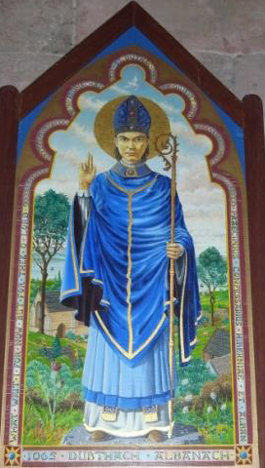

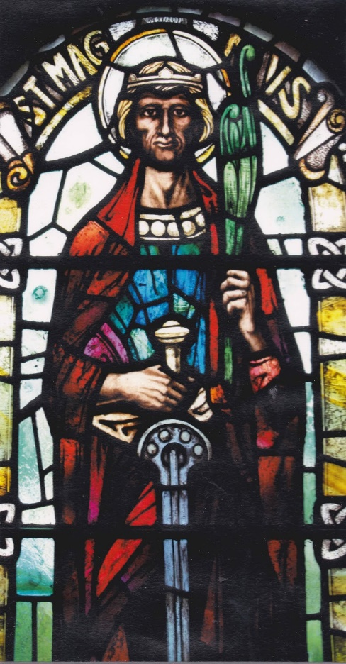
ST MAGNUS

